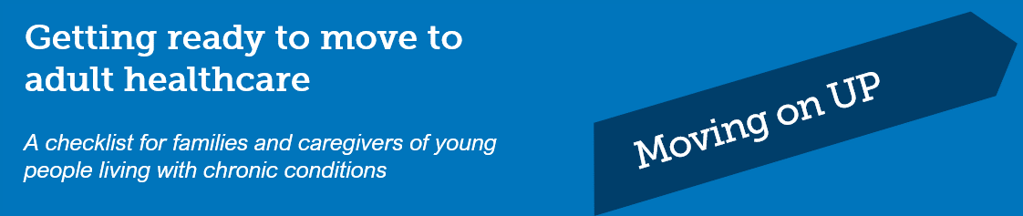

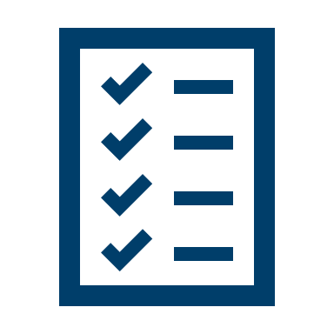

Use this checklist to identify skills your young person already has, and those areas where you may
need to help them to prepare for the move to new services.

If your young person doesn’t have a GP, ask friends, family and health professionals for recommendations. The general practitioner becomes more important as the coordinator of care once your young person leaves the children’s health services.

Healthcare Skill Area | Yes | Not yet

BUILDING KNOWLEDGE

I help my young person learn about and understand their condition. I have taught them to:
Describe their condition and explain any special healthcare needs to others
Name their medications and/or treatments, what they are for, and their dosage
Describe the side effects and restrictions of the medications they take
Know the equipment they need for treatment and what it is used for
Know any tests they have regularly and why
Get health information from dependable sources

INVOLVEMENT WITH HEALTHCARE

I encourage my young person to be involved in their own healthcare. I am teaching them to:
Make their own healthcare appointments and have the contact details of healthcare providers
Take responsibility to get themselves to healthcare appointments
Think of questions to ask before each healthcare appointment
Take time to spend with their health professionals on their own (I step out of the appointment)
Understand their rights to privacy and their role in decision-making about their healthcare
Choose to talk to their doctor without me present if they prefer

FOLLOWING A CARE PLAN

I am helping my young person to become responsible for:
Prepare and take their medication and treatments on their own
Get their prescriptions and have them filled
Be organised and keep copies of medical tests, results, clinic and discharge letters
Organise, maintain, and reorder any equipment
Keep track of their own health information (e.g. appointments, medications, test results)
Understand how they will pay for healthcare and medications
Monitor and respond appropriately to their symptoms
Know what to do when they become unwell or need urgent medical assistance

Know how to manage any allergies they have

HEALTH AND LIFESTYLE

I coach my young person to speak with their doctor about:

Stress and about how this might affect their chronic condition

How their condition may affect their mental health

Contraception and how their chronic condition might impact on fertility and pregnancy

How their chronic condition might be affected by tobacco, alcohol and drugs

Eating well and exercising regularly

SUPPORT SERVICES ARE AVAILABLE

I encourage my young person to:
Talk with supportive others about their condition (e.g. family, friends, teachers, sports coaches)
Find other support resources if needed (e.g. I help to find online resources, support groups, camps)
Investigate, with my help, whether they will be eligible for financial support or any concessions from Centrelink
Learn about the National Disability Insurance Scheme (NDIS). I have talked with NDIS on my young person’s behalf to see if there are benefits or resources available

MOVING TO ADULT HEALTHCARE

I have helped prepare for my young person’s transition.
My young person has a regular general practitioner (GP)
I know how to get my young person their own Medicare card and Health Care Card (if relevant)
I’ve discussed with my young person and their clinicians about the My Health Record
I have looked into private health insurance and whether my young person will be covered
I have talked with my young person’s GP or paediatric clinician, or other specialists about:
- what services will be available as my young person enters adulthood
- what new services my young person will transfer to
- where my young person will be referred to in the new health service(s) and whether this can be at a single location
- clinicians who will act as a key person to help with the transition to new services
- if the current treatment plan is available in the new health services
- what monitoring and ongoing tests will be required in adulthood.
I have developed a transition plan with my young person and the healthcare team
I know how to order equipment and supplies in the new services (there may be major differences).
I have spoken with the healthcare team about any concerns I have about the move
I have asked that a detailed medical summary be prepared for the new team
We have met with the new team and are familiar with the location, parking and access

